1. Data Selection

Dataset: Cross-Sectional Child Income Statistics by College Tier and Parent Income Percentile

Dataset description: The data consists of 1500 rows divided into 100 blocks of 15 rows. Each block represents a parent’s mean income percentile and is broken down into 15 different selectivity and type combinations. In total, there are 4 variables that represents parents’ information and 11 variables that give information about their kids. All the data consists of numerical values and the selectivity and type combinations are coded into 15 classes (e.g. Ivy Plus, Highly selective public, Never attending college, etc).

Motivation: We chose the dataset “Cross-Sectional Child Income Statistics by College Tier and Parent Income Percentile” with the aim to explore how one generation’s education and income impacts the next one’s in the U.S. The conclusions drawn from this analysis will enable us to acquire a deeper view of cross-sectional mobility. Also, we believe that this dataset can lead us to further investigations about the U.S. educational system and if college opportunities are fair or biased. Finally, we chose this dataset as it provides more information on both generations simultaneously than the other dataset in the assignment 1.

1. Data Preparation

After exploring the data, we found that there were very few missing values and only numerical values. Moreover, the data is structured by ascending percentiles and tier names. The tier names are encoded by numerical values and finally since the income represents averages, it is complicated to find outliers in the aggregated data. However, comparing the mean with the more robust median, it enables us to guess the presence of outliers in the sample. We concluded that this dataset is already suitable for visualization and does not need any data pre-processing.

As a first sanity check, we started by understanding what represent the data and each column of the dataset. We noticed that some data are fixed in every block, i.e. the tot_count column, the tier name and the tier values. After concluding that the dataset was clean and there was no need for data pre-processing, we will then perform the next sanity check by displaying graphs, such as bivariate scatter plot to see if there is any relationship between the columns or histograms to see the distributions of the income. With our final goal in mind, to use the relevant features to predict income variability of the second generation, we want to select the relevant features by looking at the linear dependencies among them. We notice the last column *density features* is calculated by the *count* over the *total count* feature and therefore it is linearly dependent on the count, which makes it unnecessary. All in all, reducing the number of variables enables us to visualize the data more clearly, illustrate and our sanity check, as it reduces the dimensionality.

As mentioned in the first assignment, the dataset about Cross-Sectional Statistics on Children’s Income Distributions by College Tier found on the same [data repository platform](https://opportunityinsights.org/data/?__cf_chl_tk=aG16QIOY6DRi35U.fLo0xTh5C2NKTd0AM2NN401oEMY-1643664269-0-gaNycGzNCOU), can provide further details about the future of the kids in our chosen dataset. It is a subset of the first dataset from the kids’ perspective. It enables us to complete our analysis of our chosen dataset. In particular, it helps us explore the relationship between the college type and income and to compare with the previous generation. However, we also notice that the latter dataset starts from the 9th percentile whereas our chosen dataset starts from the 1st one. Therefore, we need to explore if joining these two datasets is feasible while keeping consistency and cleanliness.

1. We are considering some of the follow Research Questions:
2. What is the link a generation’s income and education in their offspring’s future income in the U.S.?
3. What is the role of different colleges in inter-generational and economic mobility in U.S.?
4. What may be confounding factors and causalities of one generation on their offspring’s financial situation?
5. How fair are U.S. educational system and college opportunities based on one offspring’s previous generation’s income and education?
6. What is the impact of “new money” vs “old money”?
7. Chart, bar chart

   Description automatically generatedData Visualization

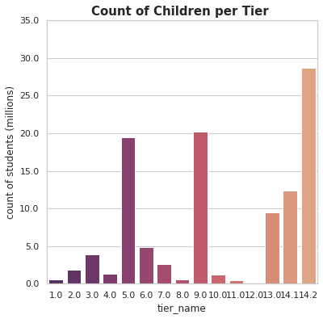

APPENDIX: